**What is Management by Objective ?**

**The process of setting objectives in the organization to give a sense of direction to the employees is called as Management by Objectives**.

It refers to the process of setting goals for the employees so that they know what they are supposed to do at the workplace.

Management by Objectives defines roles and responsibilities for the employees and help them chalk out their future course of action in the organization.

Management by objectives guides the employees to deliver their level best and achieve the targets within the stipulated time frame.

**Need for Management by Objectives (MBO)**

* The Management by Objectives process helps the employees to understand their duties at the workplace.
* KRAs are designed for each employee as per their interest, specialization and educational qualification.
* The employees are clear as to what is expected out of them.
* Management by Objectives process leads to satisfied employees. It avoids job mismatch and unnecessary confusions later on.
* Employees in their own way contribute to the achievement of the goals and objectives of the organization. Every employee has his own role at the workplace. Each one feels indispensable for the organization and eventually develops a feeling of loyalty towards the organization. They tend to stick to the organization for a longer span of time and contribute effectively. They enjoy at the workplace and do not treat work as a burden.
* Management by Objectives ensures effective communication amongst the employees. It leads to a positive ambience at the workplace.
* Management by Objectives leads to well defined hierarchies at the workplace. It ensures transparency at all levels. A supervisor of any organization would never directly interact with the Managing Director in case of queries. He would first meet his reporting boss who would then pass on the message to his senior and so on. Every one is clear about his position in the organization.
* The MBO Process leads to highly motivated and committed employees.
* The MBO Process sets a benchmark for every employee. The superiors set targets for each of the team members. Each employee is given a list of specific tasks.

**Limitations of Management by objectives Process**

* It sometimes ignores the prevailing culture and working conditions of the organization.
* More emphasis is being laid on targets and objectives. It just expects the employees to achieve their targets and meet the objectives of the organization without bothering much about the existing circumstances at the workplace. Employees are just expected to perform and meet the deadlines. The MBO Process sometimes do treat individuals as mere machines.
* The MBO process increases comparisons between individuals at the workplace. Employees tend to depend on nasty politics and other unproductive tasks to outshine their fellow workers. Employees do only what their superiors ask them to do. Their work lacks innovation, creativity and sometimes also becomes monotonous.

The 6 steps of the MBO process are;

1. Define organizational goals
2. Define employees objectives
3. Continuous monitoring performance and progress
4. Performance evaluation
5. Providing feedback
6. Performance appraisal

Let’s briefly look at each of these;

1. **Define Organizational Goals**

Goals are critical issues to organizational effectiveness, and they serve a number of purposes. [**Organizations can also have several different kinds of goals**](https://www.iedunote.com/organizational-goals), all of which must be appropriately managed.

And a number of different kinds of managers must be involved in setting goals. The goals set by the superiors are preliminary, based on an analysis and judgment as to what can and what should be accomplished by the organization within a certain period.

1. **Define Employees Objectives**

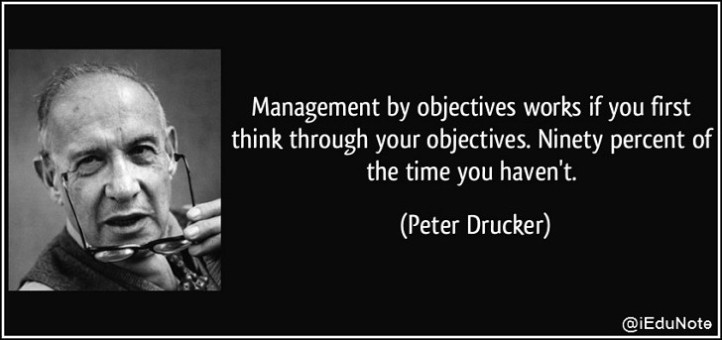

After making sure that employees’ managers have informed of pertinent general objectives, strategies and planning premises, the manager can then proceed to work with employees in setting their objectives.

The manager asks what goals the employees believe they can accomplish in what time period, and with what resources. They will then discuss some preliminary thoughts about what goals seem feasible for the company or department.

1. **Continuous Monitoring Performance and Progress**

MBO process is not only essential for making line managers in business organizations more effective but also equally important for monitoring the performance and progress of employees.

For monitoring performance and progress the followings are required;

* + - Identifying ineffective programs by comparing performance with pre-established objectives,
    - Using [**zero-based budgeting**](https://www.iedunote.com/zero-based-budgeting),
    - Applying MBO concepts for measuring individual and plans,
    - Preparing long and short-range objectives and plans,
    - Installing [**effective controls**](https://www.iedunote.com/effective-control-system), and
    - Designing a sound organizational structure with clear, responsibilities and decision-making authority at the appropriate level.

1. **Performance Evaluation**

Under this MBO process performance review is made by the participation of the concerned managers.

1. **Providing Feedback**

The filial ingredients in an MBO program are continuous feedback on performance and goals that allow individuals to monitor and correct their own actions.

This continuous feedback is supplemented by periodic formal appraisal meetings in which superiors and subordinates can review progress toward goals, which lead to further feedback.

1. **Performance Appraisal**

[**Performance appraisals**](https://www.iedunote.com/performance-evaluation) are a regular review of employee performance within organizations. It is done at the last stage of the MBO process.